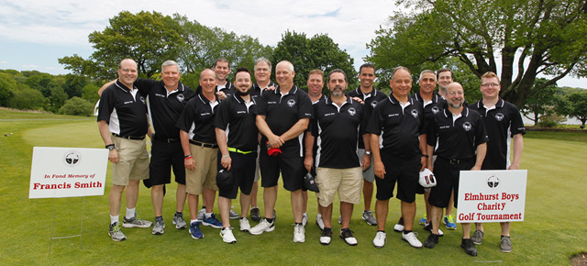
The Elmhurst Boys 6th Annual Charity Golf Tournament
Crystal Lake Golf Club
Saturday July 10, 2021 Registration 7:00 am Shotgun start 8:00 am Cost: $150 per golfer
Format: Scramble
Includes: golf, golf cart, lunch, gift bag, raffle, longest drive & closest to the pin contests, snacks, water & soft drinks.
Golfer registration:
Golfer 1__________________________________________________ Phone #__________________________________________________ Email____________________________________________________
Golfer 2__________________________________________________
Phone #__________________________________________________
Email____________________________________________________

Golfer 3__________________________________________________
Phone #__________________________________________________
Email____________________________________________________
Golfer 4__________________________________________________
Phone #__________________________________________________
Email____________________________________________________
Lunch only tickets available $50 per ticket
Please send player registration forms to:
The Elmhurst Boys, c/o Nicholas Soares
42 Maplecrest Ave, North Providence, RI 02911
Make checks payable to: The Elmhurst Boys
The Elmhurst Boys are an IRS code 501(c)3 non-profit organization.
https://elmhurstboysgolf.eventbrite.com

