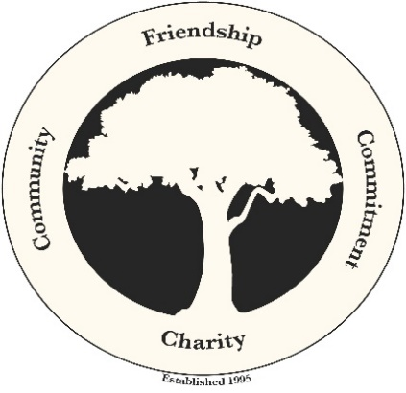

Dear Friend,

The Elmhurst Boys are proud to announce being recently named by the Diocese of Providence as a 2020 Lumen Gentium Award recipient. This award recognizes individuals, groups and organizations for their service to those in need. As part of this ongoing mission, on Saturday, July 10th, the Elmhurst Boys will host their 6th Annual Charity Golf Tournament at Crystal Lake Golf Club.

Your attendance at, and sponsorship of, this year’s tournament will help A Wish Come True, the oldest wish granting organization in Rhode Island and Massachusetts. They are not associated with any national organization. Since 1982, A Wish Come True has been granting wishes to over 1600 local children throughout Rhode Island and Southeastern Massachusetts. The mission is to grant wishes to children and youth age 3-18 suffering from a life-threatening illness who live in Rhode Island and areas of Southern Massachusetts.

Proceeds from past golf tournaments and our other events have included many worthwhile causes, including: Alexandra “Alex” Wilson, Emmanuel House in Providence, the American Red Cross, San Miquel School, First Tee, St. Pius V School, Best Buddies of RI and Rhode Island School for the Deaf. We are a 100% volunteer organization with no paid staff, thus ensuring the maximum level of funding that we can provide to charities. Visit our website at http://www.TheElmhurstBoys.com to learn more about our mission.

Information about this great day may also be found in our brochure, which includes a registration form. Please reserve your tee signs, a lunch seat, donate or secure a golfer registration by sending the form, or a note, by mail or online as noted below.

For mailing, please make checks payable to The Elmhurst Boys, and mail c/o Nicholas Soares, at 42 Maplecrest Ave, North Providence, RI 02911, or use our EventBrite tournament page, described below.

If you prefer to reserve by credit card or bank transfer online, you can do so on our Eventbrite page at:
https://elmhurstboysgolf.eventbrite.com

On behalf of the Elmhurst Boys, thank you in advance for your generous support.
Sincerely,
Thomas Zelano President, The Elmhurst Boys

